
University registration and management system

Submitted by
Samiur Rahman Rony (ID: 153402350 )
Md. Tanveer ahmed (ID: 152392303)
Tania Akter(ID: 153402355)
Nahida Khan (ID: 153402329 )

Supervised by:
Supta Richard Philip
Senior Lecturer, Department of CSE
City University, Dhaka, Bangladesh

A project Submitted in partial fulfillment of the requirements for the Bachelor of Computer Science and Engineering.
At the
City University
Dhaka, Bangladesh
6th, March, 2019

Declaration

I hereby declare that the project worked entitled “Face Detection and Recognition” submitted to the City University, is a record of original work done by us. Except as acknowledged in the text and that the project has been submitted, either in whole or in part to be in our university.

Letter of Acceptance

This project worked entitled “Face Detection and Recognition” Submitted to the department of Computer Science and Engineering, City University, Dhaka, Bangladesh is accepted by the department in partial fulfillment of the requirements for the Bachelor of Computer Science and Engineering.

Supta Richard Philip
Project Supervisor
Senior Lecturer Department of CSE
City University, Dhaka, Bangladesh

ACKNOWLEDGEMENT

I would like to thank The Almighty ALLAH that gave great health upon me in the struggle to accomplish my goals in this project. And I greatly thank my supervisor Supta Richard Philip , senior Lecturer, Department of Computer Science and Engineering, City University. He guided us Encouraged us, for his help, advice and every correction of the way. We are Specially Grateful to Supta Richard Philip , senior Lecturer, Department of Computer Science And Engineering.

Contents

Page no
- Abstract …................................................... 6
- Introduction …............................................. 6
- The history of face recognition ….............. 6
- Face detection using Haar-cascades ……… 7
- Face recognition …..…................. ................. 9
- Local binary pattern histogram ….............. 9
- Methodology ………………….…................ 10
- Face detection ……….................................... 11
- Face recognition process …………............. 12
- Training the classifier................................... 13
- Dataset directory …..…................................ 13
- Result ………………………………………. 14

Abstract
Identifying a person with an image has been popularised through the mass media. However,it is less robust to fingerprint or retina scanning. This report describes the face detection and recognition mini-project undertaken for the visual perception and autonomy module.It reports the technologies available in the Open-Computer Vision (OpenCV) library and methodology to implement them using Python. For face detection Haar-Cascades were used and for face recognition Local binary pattern histograms were used. The methodology is described including flow charts for each stage of the system.

1 Introduction
The following document is a report on the mini project for Robotic visual perception and autonomy. It involved building a system for face detection and face recognition using several classifiers available in the open computer vision library (OpenCV). Face recognition is a non-invasive identification system and faster than other systems since multiple faces can be analyzed at the same time. The difference between face detection and identification is, face detection is to identify a face from an image and locate the face. Face recognition is making the decision "whose face is it ? ", using an image database. In this project both are accomplished using different techniques and are described below. The report begins with a brief history of face recognition. This is followed by the explanation of HAAR-cascades and Local binary pattern histogram (LBPH) algorithms.

2 The History of Face Recognition
Face recognition began as early as 1977 with the first automated system being introduced By Kanade using a feature vector of human faces. In 1983, Sirovich and Kirby introduced the principal component analysis(PCA) for feature extraction. Using PCA, Turk and Pentland Eigenface was developed in 1991 and is considered a major milestone in technology . Local binary pattern analysis for texture recognition was introduced in 1994 and is improved upon for facial recognition later by incorporating Histograms(LBPH) . In 1996 Fisherface was developed using Linear discriminant analysis (LDA) for dimensional reduction and can identify faces in different illumination conditions, which was an issue in Eigenface method [6]. Viola and Jones introduced a face detection technique using HAAR cascades and ADABoost . In 2007, A face recognition technique was developed by Naruniec and Skarbek using Gabor Jets that are similar to mammalian eyes . In This project, HAAR cascades are used for face detection and Eigenface, Fisherface and LBPH are used for face recognition.

3 Face Detection using Haar-Cascades
A Haar wavelet is a mathematical fiction that produces square-shaped waves with a beginning and an end and used to create box shaped patterns to recognise signals with sudden transformations. An example is shown in figure 1. By combining several wavelets, a cascade can be created that can identify edges, lines and circles with different colour intensities. These sets are used in Viola Jones face detection technique in 2001 and since then more patterns are introduced [10] for object detection as shown in figure 1. To analyse an image using Haar cascades, a scale is selected smaller than the target image. It is then placed on the image, and the average of the values of pixels in each section is taken. If the difference between two values pass a given threshold, it is considered a match. Face detection on a human face is performed by matching a combination of different Haar-like-features. For example, forehead, eyebrows and eyes contrast as well as the nose with eyes as shown below in figure A single classifier is not accurate enough. Several classifiers are combined as to provide an accurate face detection system as shown in the block diagram below in figure 3.

Figure 1: A Haar wavelet and resulting Haar-like features.

in this project, a similar method is used efectively by identifying faces and eyes in combination resulting better face detection. Similarly, in viola Jones method, several classifies were combined to create stronger classifiers. ADA boost is a machine learning algorithm that tests out several week classifiers on a selected location and choose the most suitable . It can also reverse the direction of the classifier and get better results if necessary. Furthermore, Weight-update-steps can be updated


Figure 2: Several Haar-like-features matched to the features of Human face.

only on misses to get better performance. The cascade is scaled by 1.25 and re-iterated in order to find different sized faces. Running the cascade on an image using conventional loops takes a large amount of computing power and time. Viola Jones used a summed area table (an integral image) to compute the matches fast. First developed in 1984, it became popular after 2001 when Viola Jones implemented Haar-cascades for face detection. Using an integral image enables matching features with a single pass over the image.

Figure 3: Haar-cascade flow chart

4 Face Recognition
The following sections describe the face recognition algorithm Local binary pattern
histogram and how it is implemented in OpenCV.

Local Binary Pattern Histogram
Local binary patterns were proposed as classifiers in computer vision and in 1990 By Li Wang .The combination of LBP with histogram oriented gradients was introduced in 2009 that increased its performance in certain datasets . For feature encoding, the image is divided into cells (3 x 3 pixels). Using a clockwise or counter-clockwise direction surrounding pixel values are compared with the central as shown in figure 6. The value of intensity or luminosity of each neighbour is compared with the centre pixel. Depending if the difference is higher or lower than 0, a 1 or a 0 is assigned to the location. The result provides an 8-bit value to the cell. The advantage of this technique is even if the luminosity of the image

Figure 6: Local binary pattern histogram generating 8-bit number

is changed as in figure 7, the result is the same as before. Histograms are used in larger cells to find the frequency of occurrences of values making process faster. By analysing the results in the cell, edges can be detected as the values change. By computing the values of all cells and concatenating the histograms, feature vectors can be obtained. Images can be classified by processing with an ID attached. Input images are classified using the same process and compared with the dataset and distance is obtained. By setting up a threshold, it can be identified if it is a known or unknown face.

Figure 7: The results are same even if brightness is changed

5 Methodology
Below are the methodology and descriptions of the applications used for data gathering, face detection, training and face recognition. The project was coded in Python using a Spyder IDEs.

5.1 Face Detection
First stage was creating a face detection system using Haar-cascades. Although, training is required for creating new Haar-cascades, OpenCV has a robust set of Haar-cascades that was used for the project.Using face-cascades alone caused random objects to be identified .The flowchart of the detection system can be seen in figure 8.



Figure 8: The Flow chart of the face detection application

Classifier objects are created using classifier class in OpenCV through the cv2.CascadeClassifier() and loading the respective XML files. A camera object is created using the cv2.VideoCapture() to capture images. By using the CascadeClassifier.detectMultiScale() object of various sizes are matched and location is returned. Using the location data, the face is cropped for further verification. If satisfied a marker is placed around the face to illustrate a face is detected in the location.

5.2 Face Recognition Process
For this project LBPH algorithm is implemented independently. Linear binary pattern histograms can be implemented using OpenCV libraries.There are three stages for the face recognition as follows:

1. Collecting images IDs
2. Extracting unique features, classifying them and storing in XML files
3. Matching features of an input image to the features in the saved XML files and predict identity

5.3 Training the Classifier
OpenCV enables the creation of XML files to store features extracted from datasets using the FaceRe-cognizer class. The stored images are imported, converted to grayscale and saved with IDs in two lists with same indexes. FaceRecognizer objects are created using face recogniser class. Each recogniser can take in parameters that are described below:

cv2.face.createLBPHFaceRecognizer()
1. The radius from the center pixel to build the local binary pattern.
2. The Number of sample points to build the pattern. Having a considerable number will slow down the computer.
3. The Number of Cells to be created in X axis.
4. The number of cells to be created in Y axis.
- 5. Find the image that matches the input image we just need to compare two histograms and return the image with the closest histogram.

Recogniser object will be created and images are imported, resized, converted into numpy arrays and stored in a vector. The ID of the image is gathered from splitting the fille name, and stored in another vector. By using FaceRecognizer.train(NumpyImage, ID) the object will be trained.Next, the configuration model is saved as a XML file using FaceRecognizer.save(FileName).

Dataset directory:

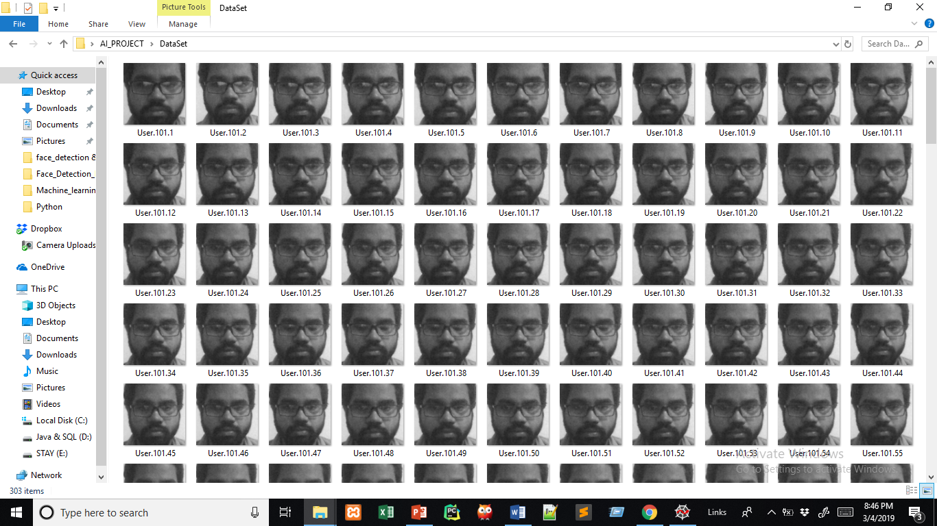

This is our dataset directory 101 images will be stored here for single ID

To find the image that matches the input image we just need to compare two histograms and return the image with the closest histogram.

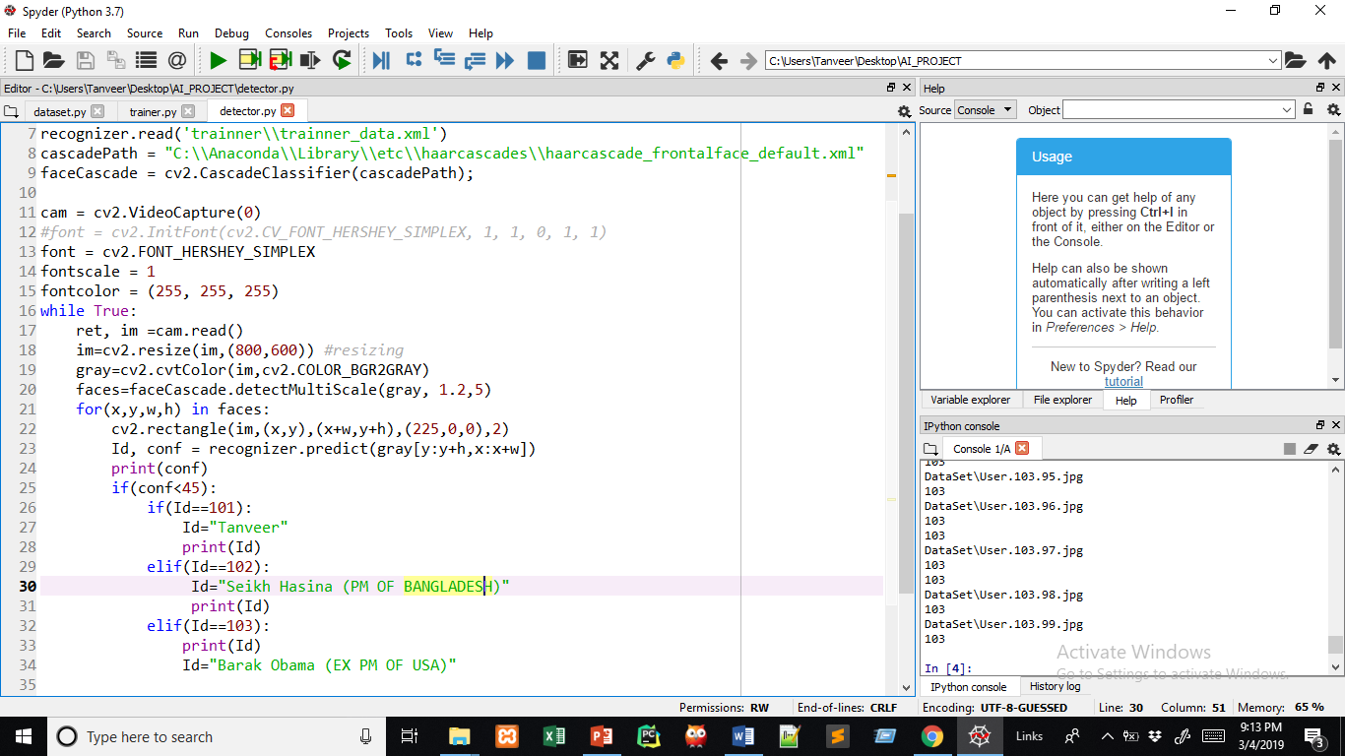
This method predict the similarities between input data and stored data

Result:


Match with dataset


Did not match with dataset

